**KV4001: White Box Testing Seminar - Running the MCC .jar Files**

1. Double click on the jar file and it should execute. You will see a GUI similar to the following:

**NOTE**: The number of input fields depends on the code being tested.

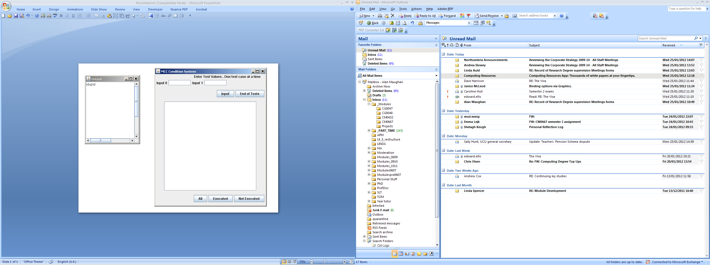

These can be used

at any time.

General output area

Output from the program appears here.

Press **input** after entering all data for each test.

Press after inputting **ALL** tests

Show conditions

that have been executed.

Show conditions

that have not been executed.

Show all conditions.

1. Type the values for a single test into the input boxes. When the values are entered click on the ‘**input**’ button. The text boxes will clear. Repeat for each test case.
2. After you have entered all your test cases, click the ‘**End of Tests**’ button. This sends a report to the general output area.
3. Clicking the ‘**End of Tests**’ button disables input. To enter more data you would need to re-run the program.
4. Note: Clicking the ‘**All**’ button shows the conditions to be tested in a separate window. In effect the window shows the truth tables you should have produced (in this case for example 0).